Coursera Capstone Project

1. Introduction: The basic idea behind this project is to cluster the neighborhoods in Toronto to get the best places to open a restaurant, a coffee shop, or a hotel.
2. Data: The data used in this project is Toronto city in Canada. Having obtained the data from [Wikipedia](https://en.wikipedia.org/wiki/List_of_postal_codes_of_Canada:_M). I then proceeded to clean it i.e. I changed from this table below

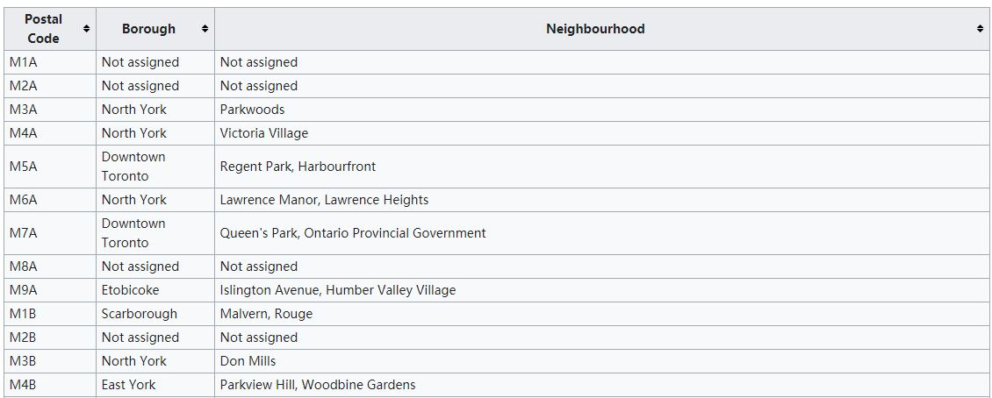

To this:

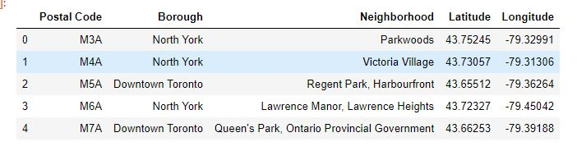

The map of the assigned neighborhoods coloring each borough differently looked something like this.

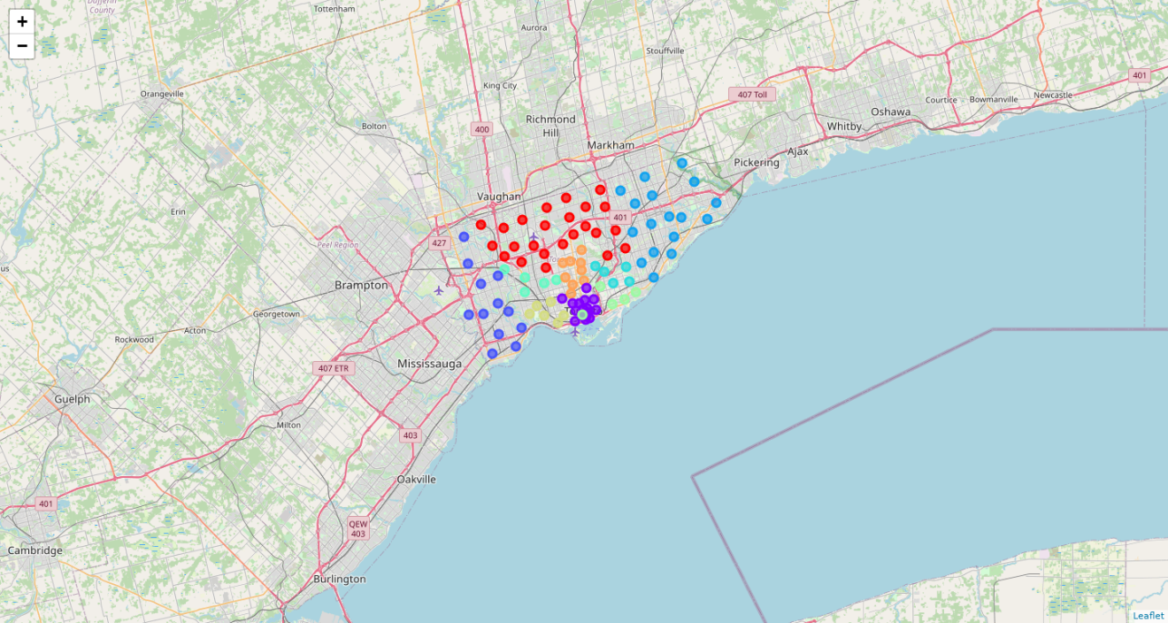

1. Methodology: firstly, the foursquare API was used to get more information about each neighborhood however I had to search for each venue separately I then combined them all in one data frame.

Now that the data has been cleaned and ready the K-means algorithm, using only three clusters the map coloring each color differently looked like this 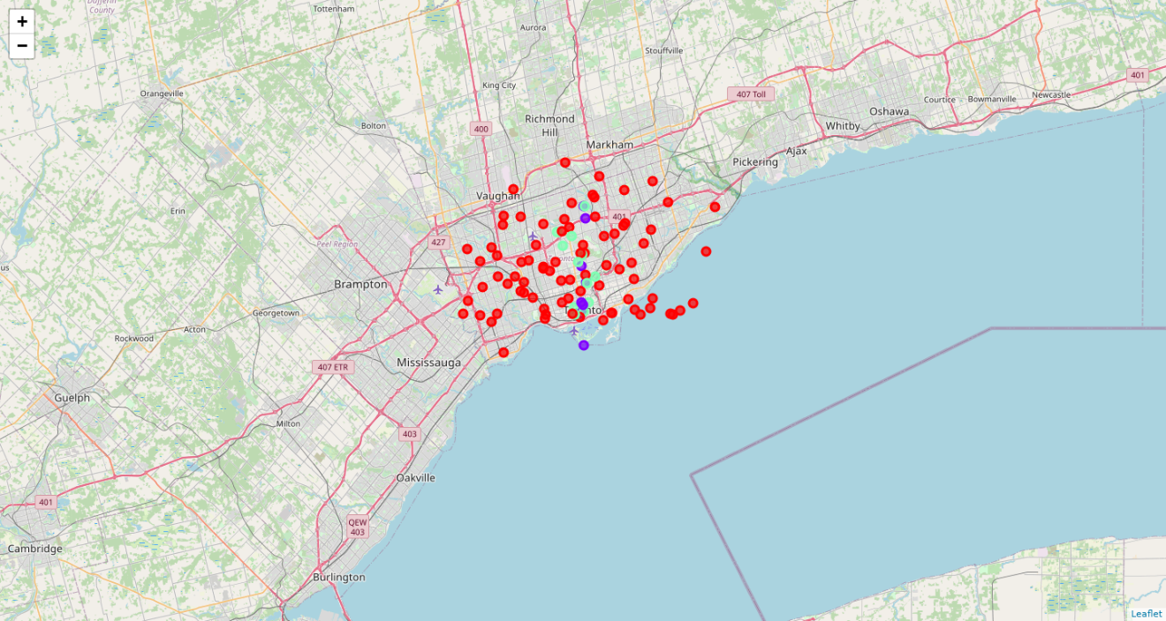

1. Results: after checking the clusters I came up with those results: the first cluster has relatively low coffee shops and restaurants, and almost no hotels

the second cluster, however, has the highest count of any cluster the third cluster is in the middle

1. Conclusion: Having checked the data we can presume that the best places to open the venues are in cluster 2 for hotels since it has the most count, the third for restaurants and coffees can be opened anywhere